 | CHAROTAR UNIVERSITY OF SCIENCE & TECHNOLOGY  DEVANG PATEL INSTITUTE OF ADVANCE TECHNOLOGY AND RESEARCH | 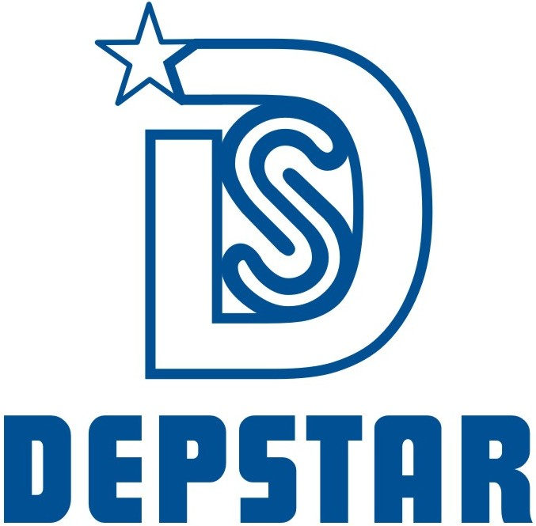

Weekly Report
In this report students require to mention the work has been done during the week and planning for the next week. (Please fill individual report for each week)

Student ID: 19DCS098 | Student Name: Parth Niteshkumar Patel
From Date: 14 June 2021 | To Date:20 June 2021
Semester: 4 | Internship ID: null

Work done in last week (Attach supporting Documents):

- Basics of CSS

- Basics of Intermediate CSS

- Completed Section-4 and Section-5 of The Complete Web Development Bootcamp.

Projects Undertaken During Internship:

Total Projects Completed: 3

Projects given: 2

Projects Completed during the current week : 2

Project Title:

- Enhance your previous portfolio website with the help of CSS

- Complete the Tin Dog Website provided in the course.

Plans for next week:

- Basics of Bootstrap
- Basics of JavaScript

References:

- The Complete Web Development Bootcamp
URL: https://www.udemy.com/course/the-complete-web-development-bootcamp/

- Instructor’s Session

Project Screenshots:

Project: Portfolio Website

Technologies Used: HTML, CSS

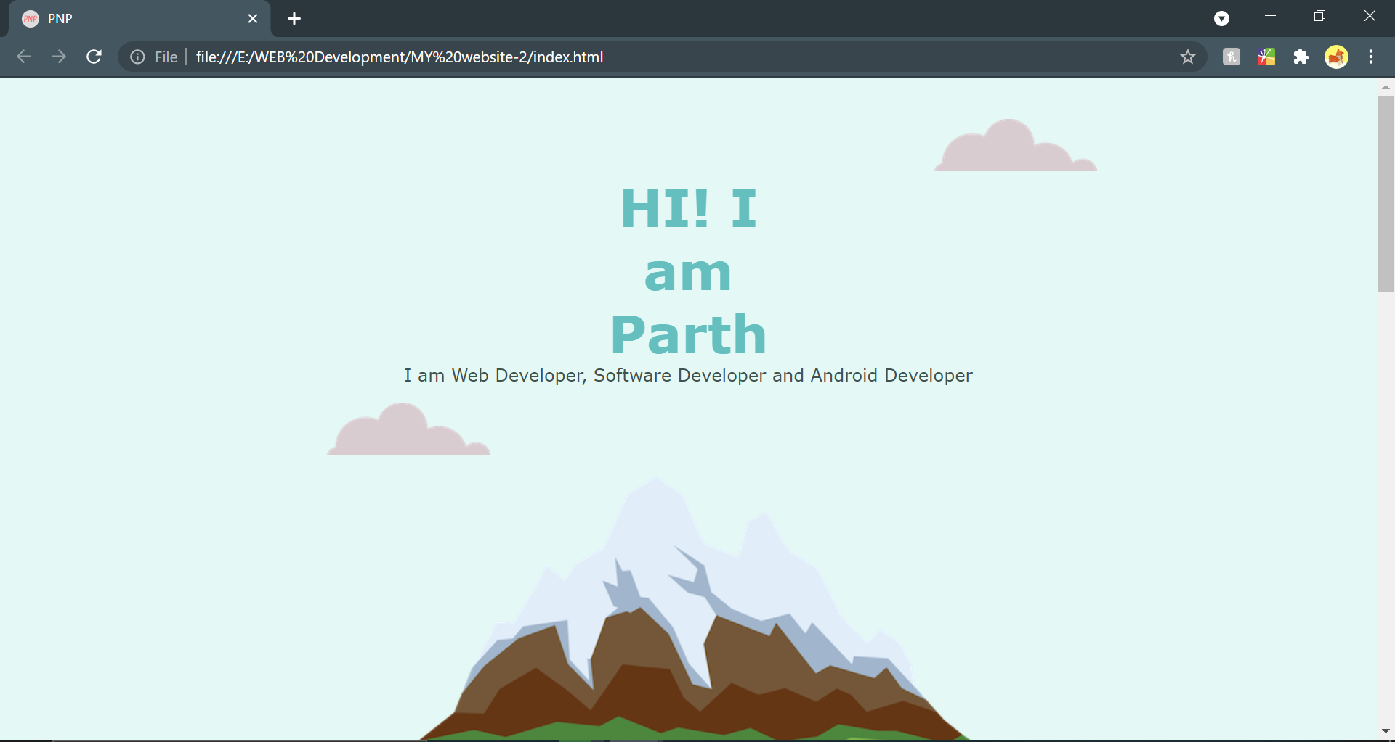

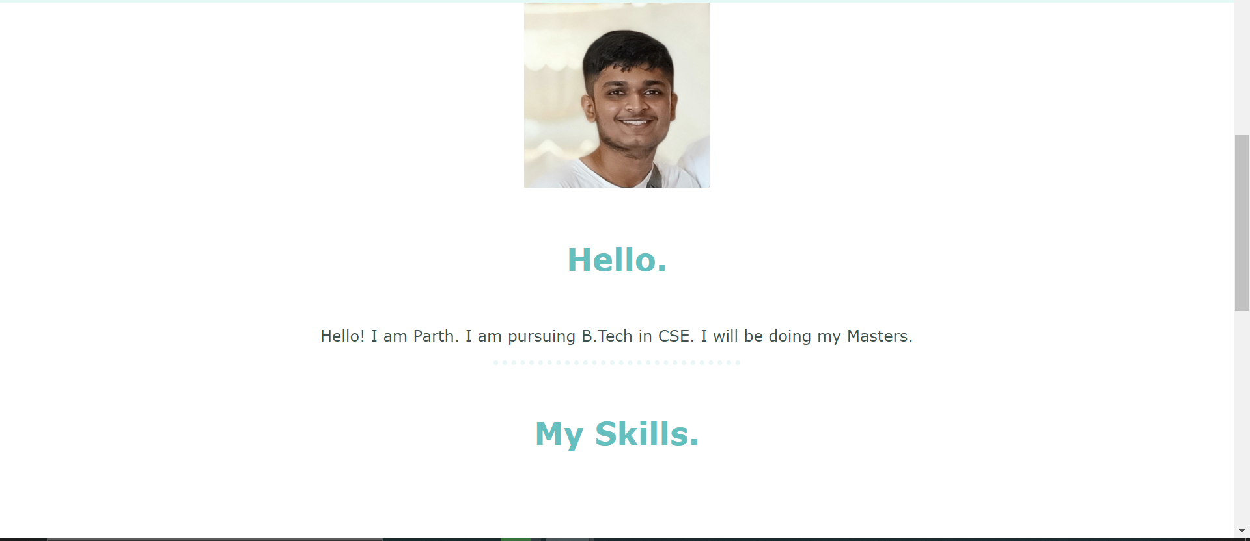
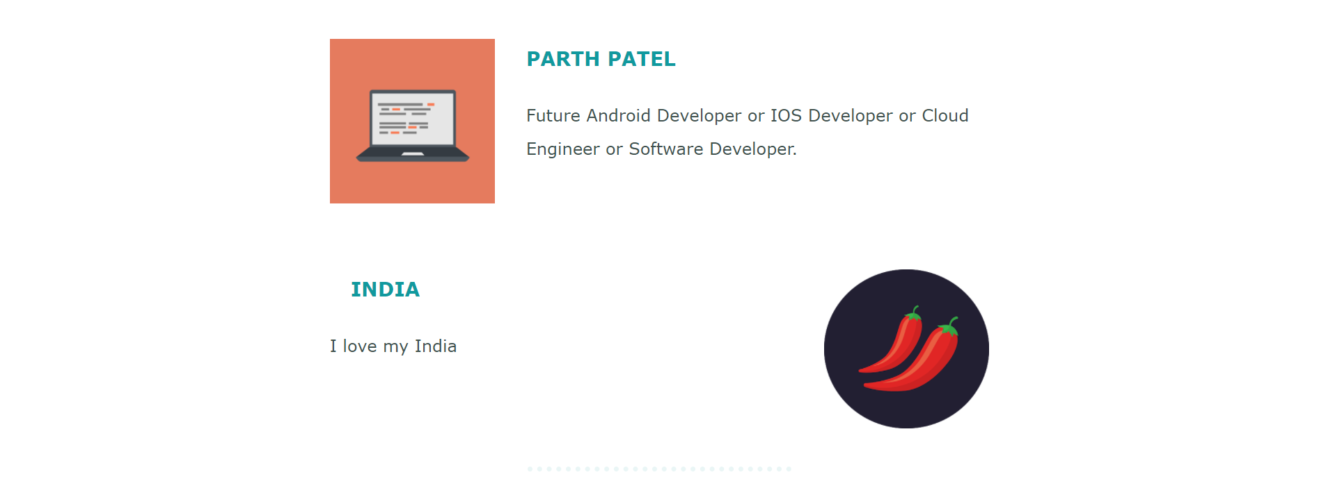



Project: Tin Dog Website

Technologies Used: HTML, CSS

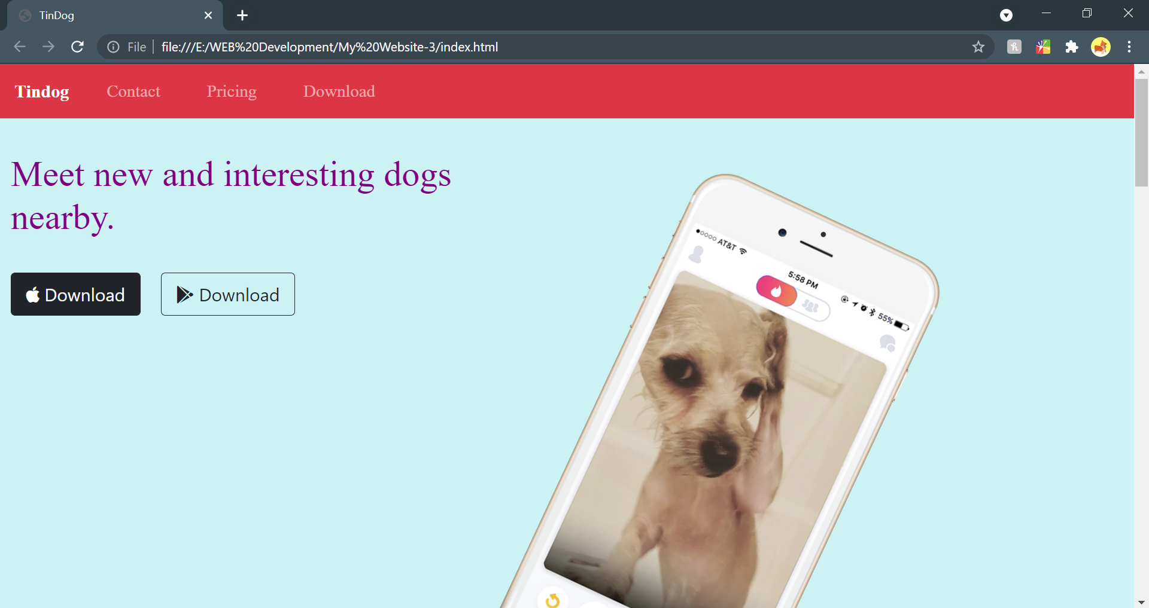
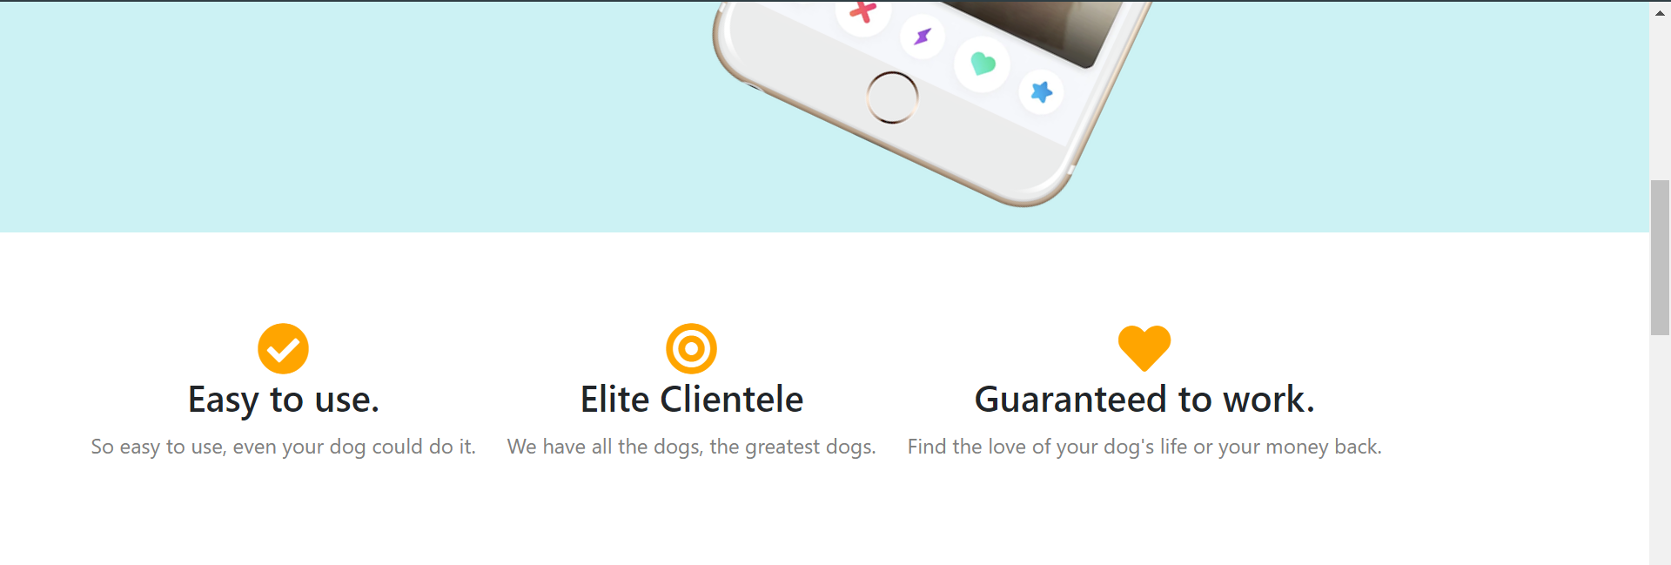

Top Section


Middle Section

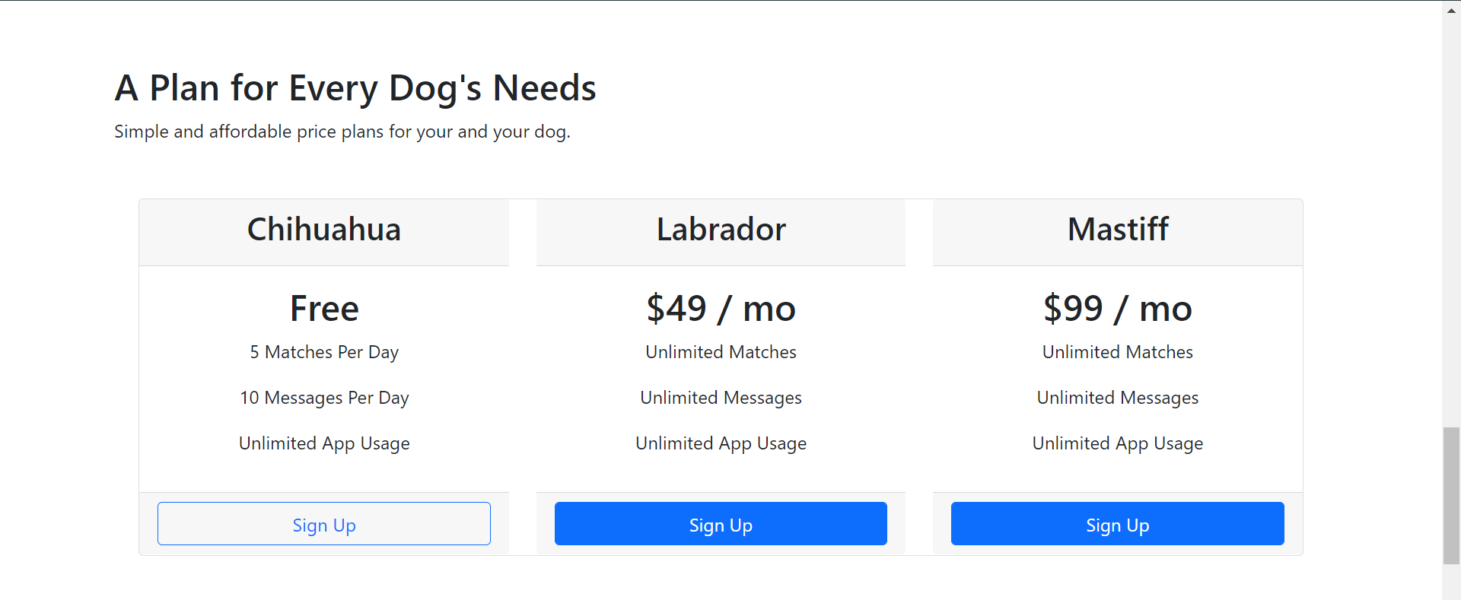

Price Section



Bottom Section

Signature of External Supervisor Signature of Internal Supervisor



Note from Supervisor: The intern has completed the project 2 and project 3 successfully on time and the project has been verified.

